File upload: <http://localhost:8080/RestWithSpringBoot/upload.jsp>

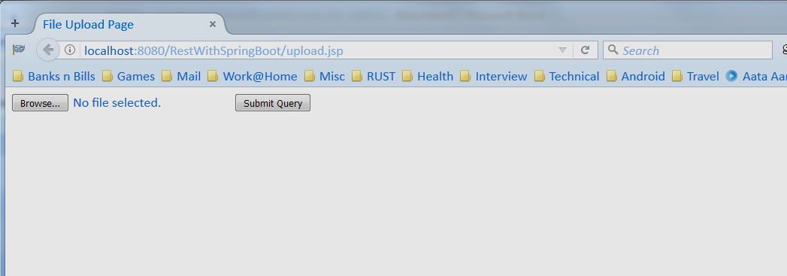

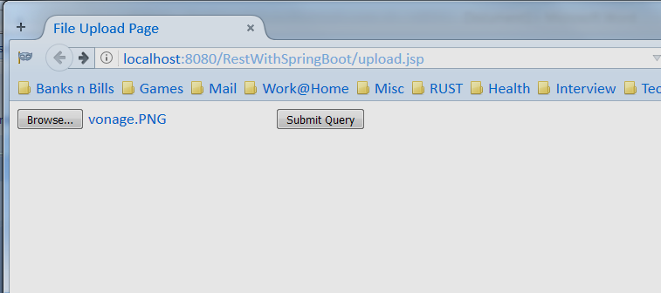

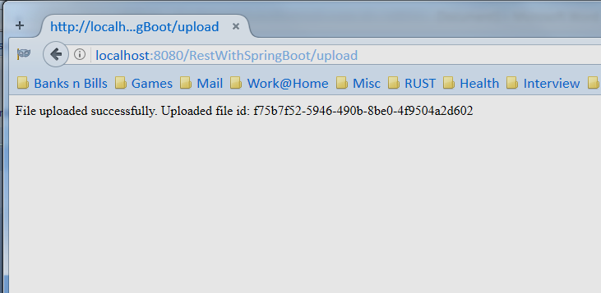

File info retrieval: <http://localhost:8080/RestWithSpringBoot/getFileInfo/>{fileid}

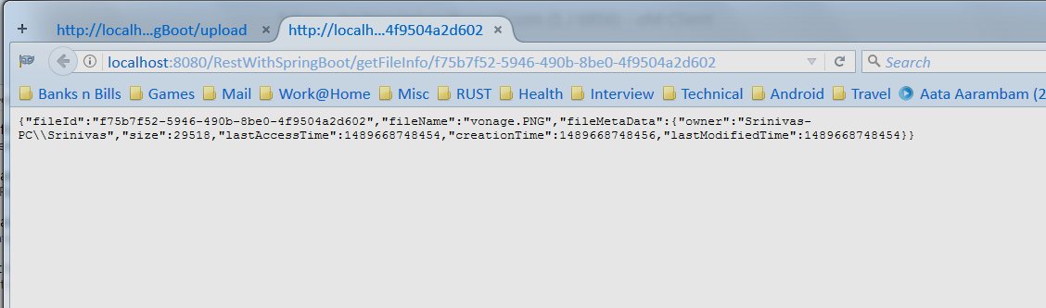

File content retrieval: <http://localhost:8080/RestWithSpringBoot/getFileContent/>{fileid}

